6. 1 Corinthians 13:8
Did Paul write that these miraculous abilities would cease?

From this study I understand that the gifts of miracles were only given by an apostle.
TRUE or FALSE

From this study I understand that the gifts of miracles served three purposes.
TRUE or FALSE

From this study I understand that we do not need miracles today to confirm these things because we have the Bible.
TRUE or FALSE

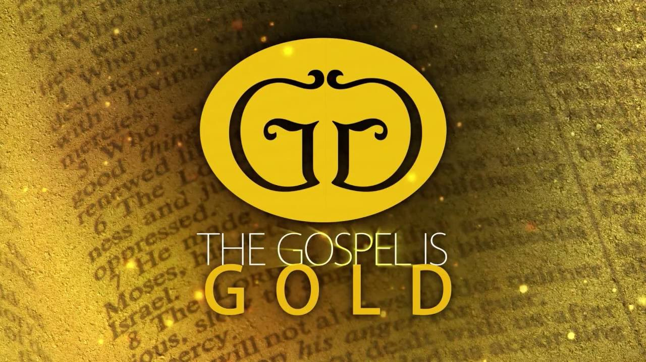

LESSON 3

“DO BIBLE MIRACLES STILL HAPPEN TODAY?”

DO YOU BELIEVE THE BIBLE CAME FROM GOD?

ARE YOU A JEW OR A GENTILE?

SHOULD WE FOLLOW THE OLD OR THE NEW TESTAMENT FOR OUR RELIGIOUS AUTHORITY?

WHAT OPPORTUNITIES HAVE YOU HAD TO STUDY ABOUT THE SUBJECT OF MIRACLES?

DO YOU BELIEVE IN THE RECORDED MIRACLES FOUND IN SCRIPTURE?

WHAT ARE THE PURPOSES OF MIRACLES?

1. JOHN 20:30-31; ACTS 2:22

Did miracles prove that Jesus is the Christ?

Why did John record these miracles?

Do we need a miracle today to prove that Jesus is the Christ or do the recorded miracles prove it for us?

What is the first purpose of a miracle?

2. MARK 16:20

Did miracles confirm the Word of God?

Has God’s Word been confirmed today?

We need miracles to confirm God’s word today. TRUE or FALSE

What is the second purpose of a miracle?

3. 2 CORINTHIANS 12:12

Did miracles verify a true apostle?

Have all the apostles been verified today?

4. 2 TIMOTHY 4:20

Paul always healed every person who was sick
TRUE or FALSE
How come Paul did not work a miracle to heal Trophimus?

Did the need for a miracle meet any of the previous purposes?

Would we need a miracle to prove Christ, confirm the Word, or verify a true apostle today?

HOW WERE MIRACULOUS ABILITIES GIVEN?

5. Acts 8:14, 17-20
Do these verses teach that miraculous abilities from the Holy Spirit were given by an apostle?

Apostles were the only people who could give these abilities.
TRUE or FALSE

If miracles were only given by an apostle, what happened to these abilities when the apostles died?

