IS SPEAKING IN TONGUES GIBERISH OR A REAL LANGUAGE THAT EXISTS IN THE WORLD? (FRENCH, SPANISH, CHINESE, HINDI, ETC.)

6. 1 CORINTHIANS 14:26-28

WERE THESE PEOPLE ALLOWED TO SPEAK OUT WHENEVER THEY FELT NECESSARY?

THEY WERE ALLOWED TO SPEAK IN TONGUES WITHOUT AN INTERPRETER. TRUE or FALSE

7. 1 CORINTHIANS 13:8

DID THE APOSTLE TEACH THAT SPEAKING IN TONGUES WOULD CEASE?

DO WE NEED THIS MIRACULOUS ABILITY TODAY?

NOTES

______________________________________

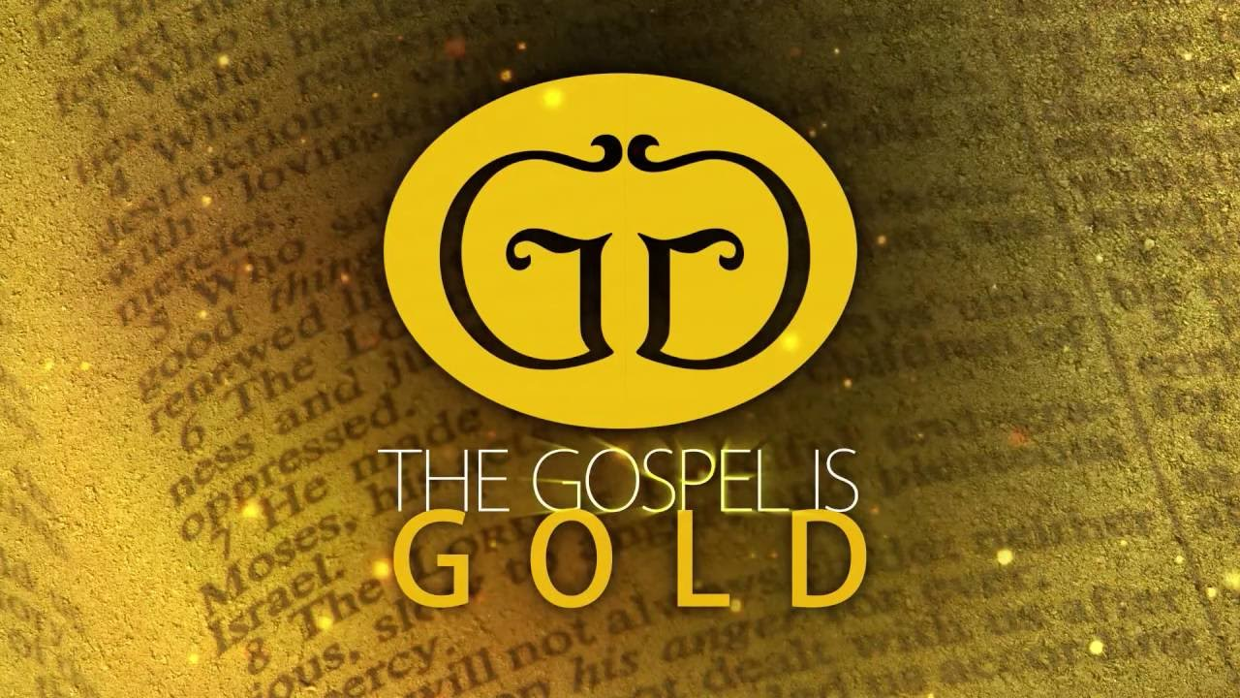

LESSON 10

“SPEAKING IN TONGUES”

DO YOU BELIEVE THE BIBLE IS THE COMPLETE WORD OF GOD?

WE FOLLOW THE TEN COMMANDMENTS OR TEACHINGS OF CHRIST TODAY.

FAITH, REPENTANCE, CONFESSION, AND BAPTISM ARE ALL NECESSARY TO BE ADDED TO THE CHURCH
TRUE or FALSE

HOW MANY CHURCHES DID JESUS BUILD?

ARE YOU FULLY COMMITED TO JESUS TODAY?

1. MARK 16:20
A MIRACLE WAS PERFORMED TO CONFIRM GOD’S WORD WAS TRUE. TRUE or FALSE

2. JOHN 20:30-31
A MIRACLE WAS PERFORMED TO PROVE THAT JESUS IS THE CHRIST. TRUE or FALSE

3. 2 CORINTHIANS 12:12
A MIRACLE WAS PERFORMED TO VERIFY A TRUE APOSTLE. TRUE or FALSE

4. ACTS 2:1-11

WHAT WAS SPEAKING IN TONGUES?

WHAT NATIONS WERE REPRESENTED HERE WHEN THE CHURCH BEGAN? (verse 5).

DID THE PEOPLE HEAR THE APOSTLES IN THEIR OWN LANGUAGE? (verse 6).

THESE PEOPLE FROM MANY NATIONS SPOKE DIFFERENT LANGUAGES. TRUE or FALSE

DID THE PEOPLE NEED A MIRACLE IN ORDER TO UNDERSTAND THE APOSTLES WHO SPOKE HEBREW?
SPEAKING IN TONGUES IS A REAL LANGUAGE THAT YOU HAVE NEVER STUDIED BEFORE.
TRUE or FALSE

THIS ABILITY IS A MIRACLE. TRUE or FALSE

5. 1 CORINTHIANS 12:8-10

DOES THE BODY HAVE MANY MEMBERS?

THE CHURCH IN THE FIRST CENTURY WAS GIVEN MIRACULOUS ABILITIES TO HELP THEM GROW.

TRUE or FALSE

DID ALL MEMBERS WORK MIRACLES?

DID ALL SPEAK IN TONGUES?

DID ALL INTERPRET TONGUES?

6. 1 CORINTHIANS 14:22-23

SPEAKING IN TONGUES WAS TO CONVINCE UNBELIEVERS. TRUE or FALSE

PROPHESYING WAS TO CONVINCE THOSE WHO ALREADY WERE BELIEVERS. TRUE or FALSE

